**PONDICHERRY UNIVERSITY**

**(A Central university)**



**SCHOOL OF ENGINEERING AND TECHNOLOGY**

**DEPARTMENT OF COMPUTER SCIENCE**

**MASTER OF COMPUTER SCIENCE**

**NAME**: Anusree K

**REG. NO:** 23370079

**SUBJECT:**Information Security Management

**TOPIC:**IT Asset Management

# Introduction

Computer labs are vital spaces for academic learning, research, and professional development, equipped with various electrical assets that support computing tasks such as data processing, software development, and networking. These assets, including desktop computers, servers, and networking devices, play essential roles in facilitating efficient operations and fostering collaboration among users.

However, while these tools are critical for productivity, they also present inherent risks. Issues such as overheating, electrical shocks, and potential data breaches can arise if safety protocols and maintenance practices are not strictly followed. Regular inspections, proper ventilation, and secure configurations are essential to mitigate these risks and ensure a safe working environment.

## 1. Network Cabinet

A Network Cabinet, sometimes called a server or data cabinet, is an enclosed structure designed to store and organize networking and server equipment securely. Found in data centers, offices, labs, and other tech-heavy environments, network cabinets help protect equipment, manage cable organization, and improve airflow to prevent overheating.

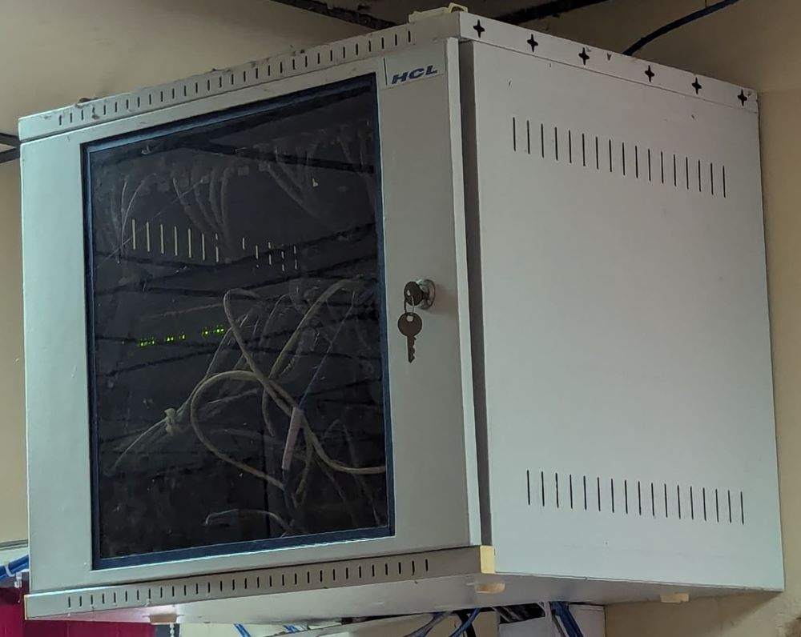

**Role of Network Cabinets:**

* Physical Security: Network cabinets protect valuable networking equipment (e.g., routers, switches, servers) from unauthorized access and accidental damage.
* Cable Management: Cabinets keep cables organized and accessible, preventing tangling and accidental disconnections.
* Efficient Cooling: Most cabinets are designed with ventilation or cooling features that help prevent equipment from overheating.
* Space Optimization: By mounting equipment vertically, cabinets allow for efficient use of space, especially in tech labs and server rooms.
* Noise Reduction: Enclosed cabinets can reduce the noise produced by running equipment, creating a quieter environment.

**Risks Associated with Network Cabinets:**

1. Unauthorized Access: Cabinets without secure locks can be accessed by unauthorized individuals, leading to data breaches or hardware tampering.
2. Overheating: Poor airflow or inadequate cooling can cause equipment to overheat, potentially leading to system failures.
3. Power Overload: Insufficient power distribution or power surges can damage equipment if power demands are too high.
4. Cable Management Issues: Poor organization can make troubleshooting difficult, increase the risk of accidental disconnection, and even cause physical strain on cables.
5. Dust and Environmental Contaminants: Dust and other particles can accumulate inside cabinets, potentially damaging sensitive electronics over time.

**Mitigation Strategies:**

1. Secure Cabinets with Locks: Install secure locks and restrict access to authorized personnel only.
2. Implement Proper Cooling Solutions: Use fans, vents, or even air conditioning units in server rooms to maintain optimal temperatures.
3. Use PDUs with Surge Protection: Distribute power evenly to prevent overloads and use PDUs with surge protection to guard against electrical surges.
4. Organize Cables Carefully: Use cable trays, Velcro ties, and labeling to keep cables tidy, reducing strain and making maintenance easier.
5. Regular Maintenance: Clean cabinets periodically to remove dust and inspect equipment for signs of wear or damage.

## 2. Uninterruptible Power Supply (UPS)

* **Primary Use**: Provides backup power during electrical outages to prevent data loss and hardware damage.
* **Risks**:
  + **Battery Leakage**: Battery failure can lead to acid leaks, causing potential burns and equipment damage.
  + **Electric Shock**: Handling live terminals can lead to shock hazards.
* **Maintenance**: Regularly inspect and replace batteries; check for leaks.
* **Mitigation**:
  + **Regular Testing**: Perform tests to ensure backup functionality.
  + **Ventilation**: Install UPS units in ventilated areas to prevent overheating.
* **Safety Note**: Avoid direct contact with battery terminals and follow UPS operation protocols.

## 3. Server Rack

* **Primary Use**: Hosts servers for data processing, file storage, and networking services, supporting lab operations.
* **Risks**:
  + **Overheating**: High-density components can cause thermal buildup.
  + **Electric Shock**: Exposed cables and power sources present shock risks.
* **Maintenance**: Check cables, power supply, and clean airflow paths regularly.
* **Mitigation**:
  + **Cable Management**: Use labeled cables and secure connections.
  + **Cooling Solutions**: Install fans or air conditioning units to reduce overheating.
* **Safety Note**: Ensure only authorized personnel have access to server racks.

## 4. Network Switches

* **Primary Use**: Facilitates data communication between computers, supporting internet and local network connectivity.
* **Risks**:
  + **Data Security**: Improper setup can lead to unauthorized access.
  + **Overheating**: Continuous operation may lead to overheating.
* **Maintenance**: Inspect ports and cables, and monitor for any network congestion.
* **Mitigation**:
  + **Secure Configurations**: Use firewalls and proper password protocols.
  + **Ventilation**: Ensure that switches are placed in ventilated areas.
* **Safety Note**: Avoid stacking switches to allow adequate air circulation.

## 5. Printers (Laser/Inkjet)

* **Primary Use**: Print documents and visuals, aiding in research and documentation.

* **Risks**:
  + **Fire Hazard**: Paper jams in laser printers can cause overheating.
  + **Toner Inhalation**: Fine toner particles pose respiratory risks.
* **Maintenance**: Clean the printer, remove paper jams, and replace cartridges as needed.
* **Mitigation**:
  + **Proper Ventilation**: Operate in well-ventilated areas to disperse fumes.
  + **Regular Inspection**: Check for paper jams and clear them promptly.
* **Safety Note**: Follow the manufacturer’s cleaning instructions to avoid inhaling toner particles.

## 6. Monitors

* **Primary Use**: Displays visual data, essential for interfacing with computers in various tasks.

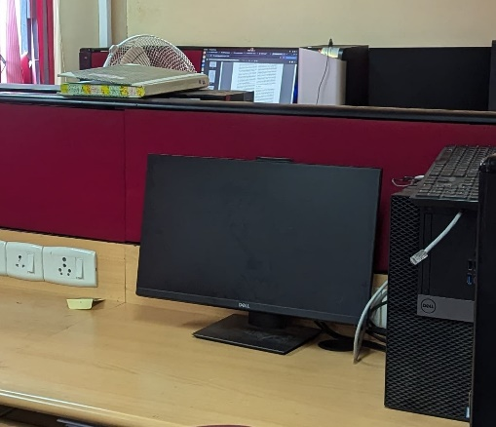

* **Risks**:
  + **Eye Strain**: Prolonged use can cause eye strain or discomfort.
  + **Electric Shock**: Damaged or frayed cords may lead to shocks.
* **Maintenance**: Dust the screen and check cables for wear.
* **Mitigation**:
  + **Screen Guards**: Use screen protectors to reduce glare and eye strain.
  + **Proper Wiring**: Regularly inspect and replace frayed cables.
* **Safety Note**: Position monitors at a comfortable distance to reduce eye strain.

## 7. Network Routers

* **Primary Use**: Provides internet connectivity for all computers within the lab.
* **Risks**:
  + **Overheating**: Prolonged operation can cause overheating.
  + **Data Breach**: Poor security measures increase the risk of cyberattacks.
* **Maintenance**: Update firmware regularly and ensure clean airflow.
* **Mitigation**:
  + **Enable Firewall**: Protects against unauthorized access.
  + **Ventilation**: Place in an open area to prevent overheating.
* **Safety Note**: Secure all cables to avoid tripping hazards and maintain network stability.

## 8. Projector

* **Primary Use**: Displays presentations or tutorials, essential for group sessions and lectures.

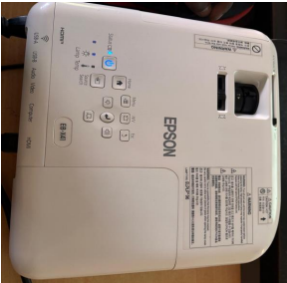

* **Risks**:
  + **Eye Damage**: Directly looking into the projector light can damage eyes.
  + **Overheating**: Continuous use can lead to overheating.
* **Maintenance**: Clean the lens, replace bulbs, and ensure adequate ventilation.
* **Mitigation**:
  + **Automatic Shutoff**: Set timers to avoid overheating.
  + **Proper Installation**: Mount securely to prevent tipping hazards.
* **Safety Note**: Avoid looking directly into the projector beam to prevent eye damage.

## 9. External Hard Drives

* **Primary Use**: Provides additional storage for data backup, essential for data redundancy and storage.
* **Risks**:
  + **Data Loss**: Mishandling or dropping can cause data corruption.
  + **Overheating**: Prolonged use without breaks can lead to overheating.
* **Maintenance**: Regularly check drive health and clean connectors.
* **Mitigation**:
  + **Protective Cases**: Use cases to prevent physical damage.
  + **Limit Use Time**: Avoid long, continuous operation to prevent overheating.
* **Safety Note**: Backup data regularly to avoid data loss.

## 10. Portable Power Strips

* **Primary Use**: Provides multiple power outlets for plugging in various devices in the lab.
* **Risks**:
  + **Overloading**: Plugging in too many high-power devices can lead to fire hazards.
  + **Electric Shock**: Damaged strips can cause electric shock.
* **Maintenance**: Check for wear and replace when necessary.
* **Mitigation**:
  + **Avoid Overloading**: Limit the number of devices plugged in.
  + **Use Surge Protectors**: Prevents damage from power surges.
* **Safety Note**: Do not use power strips with high-wattage devices and ensure all plugs are securely connected.

## Conclusion

The use of electrical assets in a computer lab is crucial to supporting various academic, research, and operational activities. With the appropriate precautions—such as regular maintenance, secure configurations, and ensuring proper ventilation—users can mitigate risks associated with electrical hazards, data security threats, and equipment damage. The implementation of these protocols helps maintain a safe and efficient environment for all users within the computer lab.